**Jammu & Kashmir**

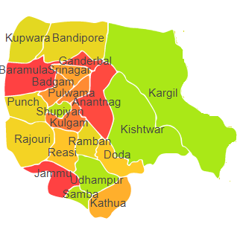

Jammu & Kashmir comprises of Agro Ecological Region (AER) 14.

**Agro-Eco Region 14 :** AER 14 in Jammu & Kashmir comprises of Anantnag, Baramula, Chilas, Gilgit Wazarat, Jammu, Kathua, Muzaffarabad, Punch, Riasi, Tribal Territory and Udhampur districts of Western Himalayas under Agro Ecological Sub Regions (AESR) 14.1 and 14.2.

**AESR 14.1 :** The region is cold and warm by dry semi-arid/dry subhumid ESR with shallow to medium deep loamy Brown Forest and Podzolic soils, low to medium AWC and LGP 90-120 days in a year.